**Grouping Product Features Using Semi-Supervised Learning**

**with Soft-Constraints**

**1 Introduction\***

One form of opinion mining in product reviews is to produce a feature-based summary.

We call these two pieces of prior knowledge *soft constraints* because they constrain the featureexpressions to be in the same feature group. Theconstraints are soft (rather than hard) as they canbe relaxed in the learning process.

In summary, this paper makes three main contributions:

1. It proposes a new sub-problem of opinion mining.

2. An EM formulation is used to solve the problem.

3. It is shown experimentally the new method outperforms the main existing state-of-the-art methods that can be applied to the task.

**2 Related Work**

**3 The Proposed Algorithm**

**3.1 Semi-Supervised Learning Using EM**

**3.2 Proposed Soft-Constrained EM**

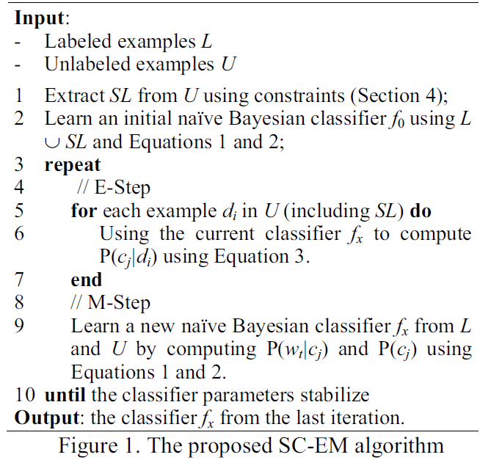

**4 Generating SL Using Constraints**

For easy reference, we reproduce them here:

1. Feature expressions sharing some common words are likely to belong to the same group.

2. Feature expressions that are synonyms in a dictionary are likely to belong to one group.

**5 Distributional Context Extraction**

**6 Empirical Evaluation**

**7 Conclusion**